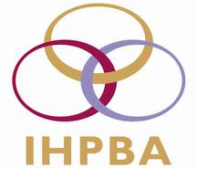

IHPBA is seeking new committee members who are enthusiastic, committed and have the time, experience and qualities required to make a difference to the Association. If you feel that you have something to contribute, please send the following information to alison@ihpba.org
Name: |  | Date of Birth:
Institution: |  | Country:
Email address

I have been a member of IHPBA for years.

I would like to serve on the following committee:

Please detail your qualifications and qualities which you consider relevant in fulfilling this role, for example past council or committee work, publishing, social media skills, key links with industry, educational leadership, research strategy, conference organisation, charitable/philanthropic activity, governance, audit roles, leadership roles in surgery.

Please detail any similar roles or relevant experience within other organisations:

Please detail any other supporting information:

Please give the name of an IHPBA member who will provide a letter of support:

…………………………………………………………………………………………………………………………………………………………….

